**Conestoga College – SET**

**Conestoga Trip**

**User Manual**

**Name : Charng Gwon Lee,**

**Hyungbum Kim,**

**Younchul Cho**

**Date of Submission : 2020-03-14**

Mobile Application Development

(PROG 3150)

**Table of Contents**

Section 1. Program outline 3

Section 2. JSON server 3

Section 3. Database 4

Section 4. Diagrams 5

Section 5. Main Program 6

Section 5.1 Splash page (splash activity) 6

Section 5.2 Main page (person activity) 7

Section 5.3 Flight information page (flight info activity) 8

Section 5.4 Trip page (trip activity) 9

Section 5.5 Confirm page (confirm activity) 10

# Program outline

This mobile application is help people to reserved trip schedule. The user can select the departure and destination airport and the number of people go to trip. After all of that, the application will show the result of reserved. Additionally, this program will give many functions to comfortable for the users.

# JSON server

This program will download some information from the JSON server. It will download two JSON files. On of that is the information which is contained the name of cites (airports) and the list of times. The other is that it includes the script of TTS. Those JSON files in the “server_json” folder which is called “flighttime.json” and “tts.json”. For convenience, I made a batch file, which called "json.bat", and it will run a JSON server automatically when you execute this file.

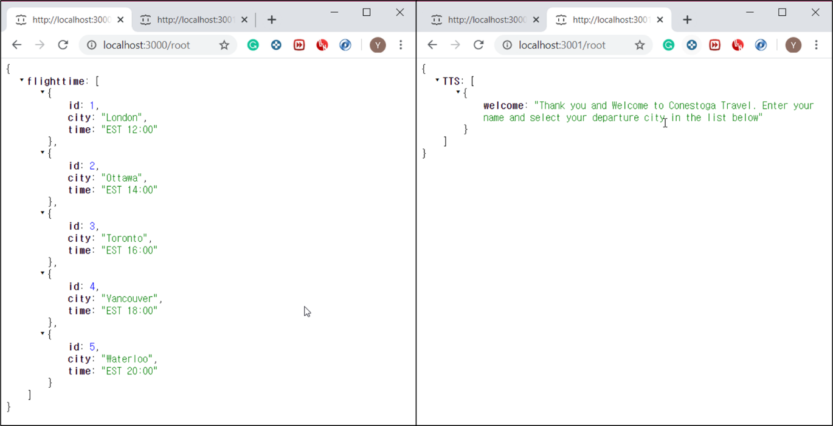

Figure 1 JONS files

# Database

The necessary information, such as airport, time, and user's name, is store in each table of the database. Also, final data, which is selected by the user, will store the "Task" table into the database.

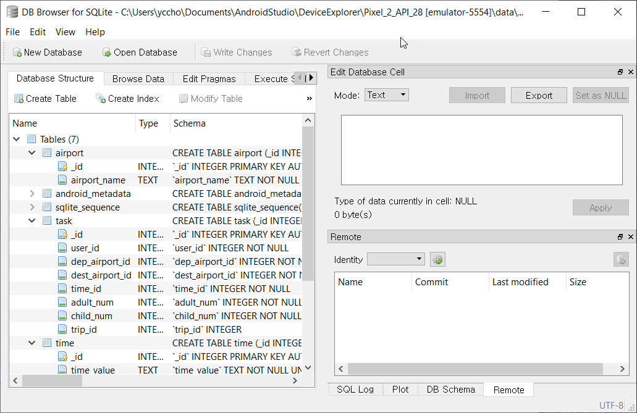

Figure 2 Database structure

# Diagrams

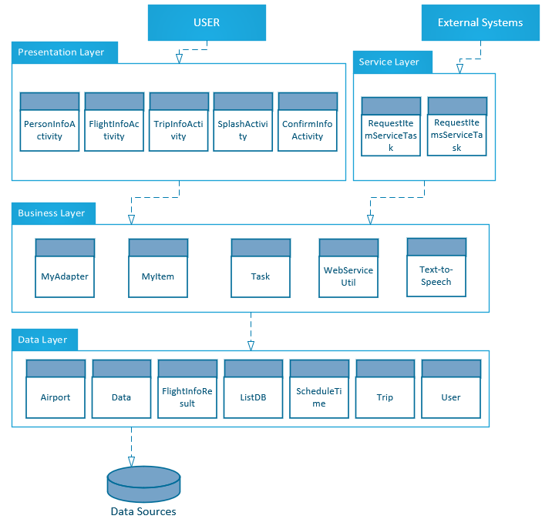

# Main Program

## Splash page (splash activity)

The splash page is up when the user starts the application. It will give some time to ready for the database. During this time, the program run asynchrony to download the information from the JSON server and store it into the database.

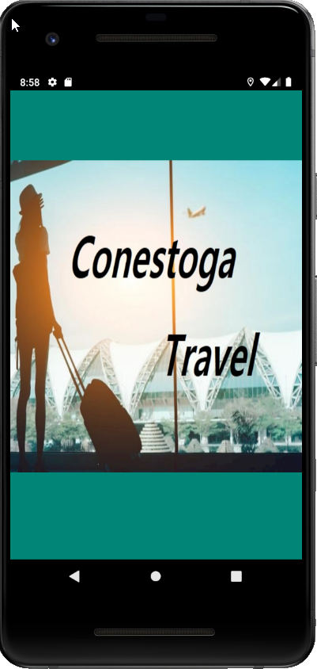

Figure 3 Splash page

## Main page (person activity)

On this page, the user will input their name and select the departure city (airport). There are two buttons on the bottom side, one of that is going to the next page, and the other is to give a guide as voice (TTS). Additionally, there is the menu button on the right top position. It will help to navigate the other pages.

Here, it uses a text edit widget to input the user's name and to use the spinner to select the city (airport). The list of the city name will load from the database. Also, toast shows up when the user selects the departure city.

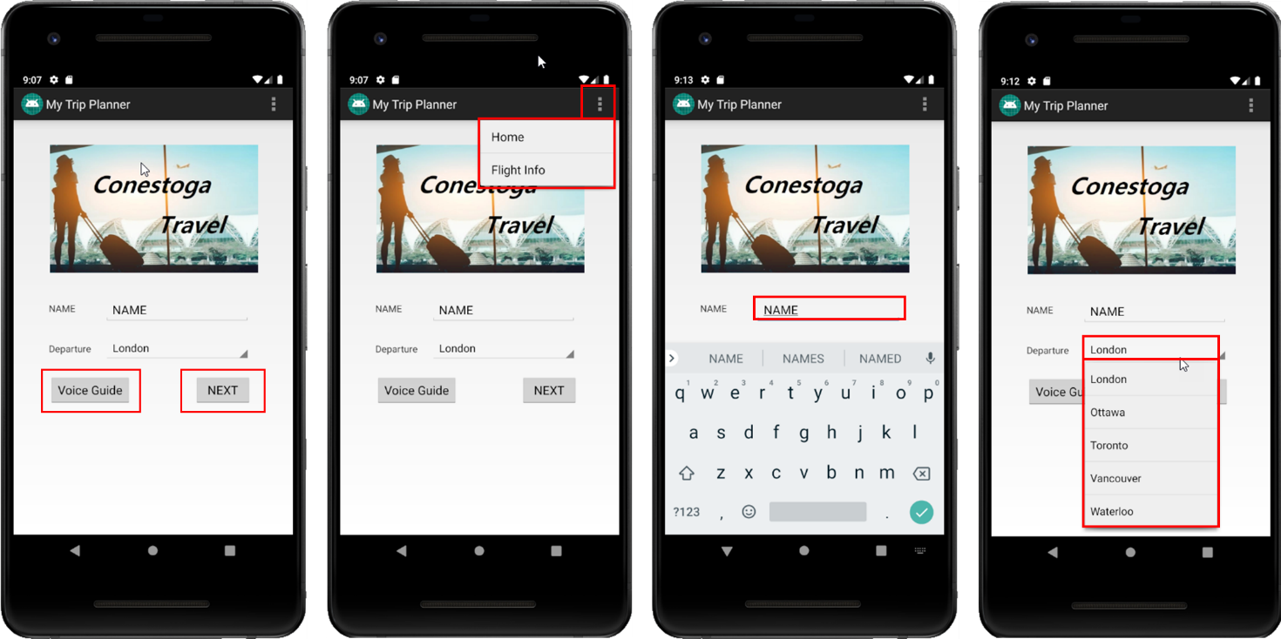

Figure 4 Main page

## Flight information page (flight info activity)

The user will access this page by the menu button. This page will show the list of cities, which is load from the database. Also, it has two buttons. On of that goes back to the main page. The other one is "external" intent to open the web site.

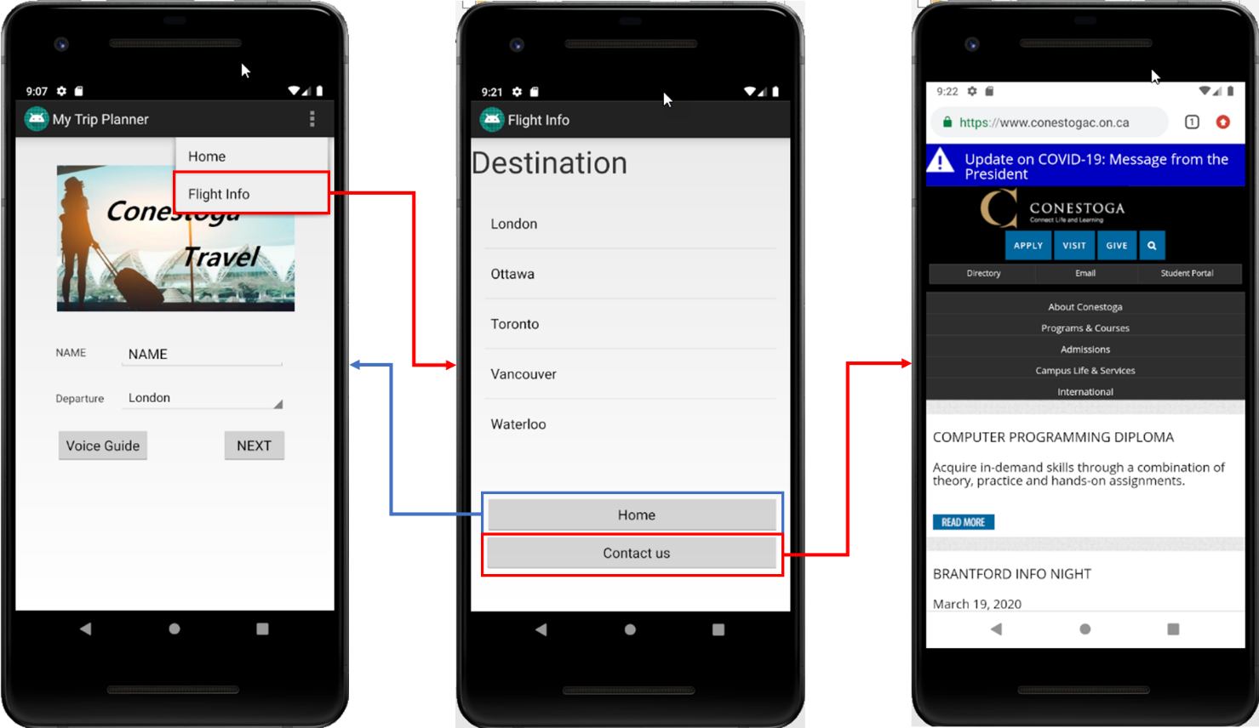

Figure 5 Flight info page

## Trip page (trip activity)

On this page, the user will select the detail information about their trip. The destination city information will get from the database. On this page, it has several widgets, such as list view, radio button, and spinner. On the top right side, it shows the user name, which is inputted by the user on the main page.

When the user confirms after the choose their trip, the application will store each information into the database table which called "task".

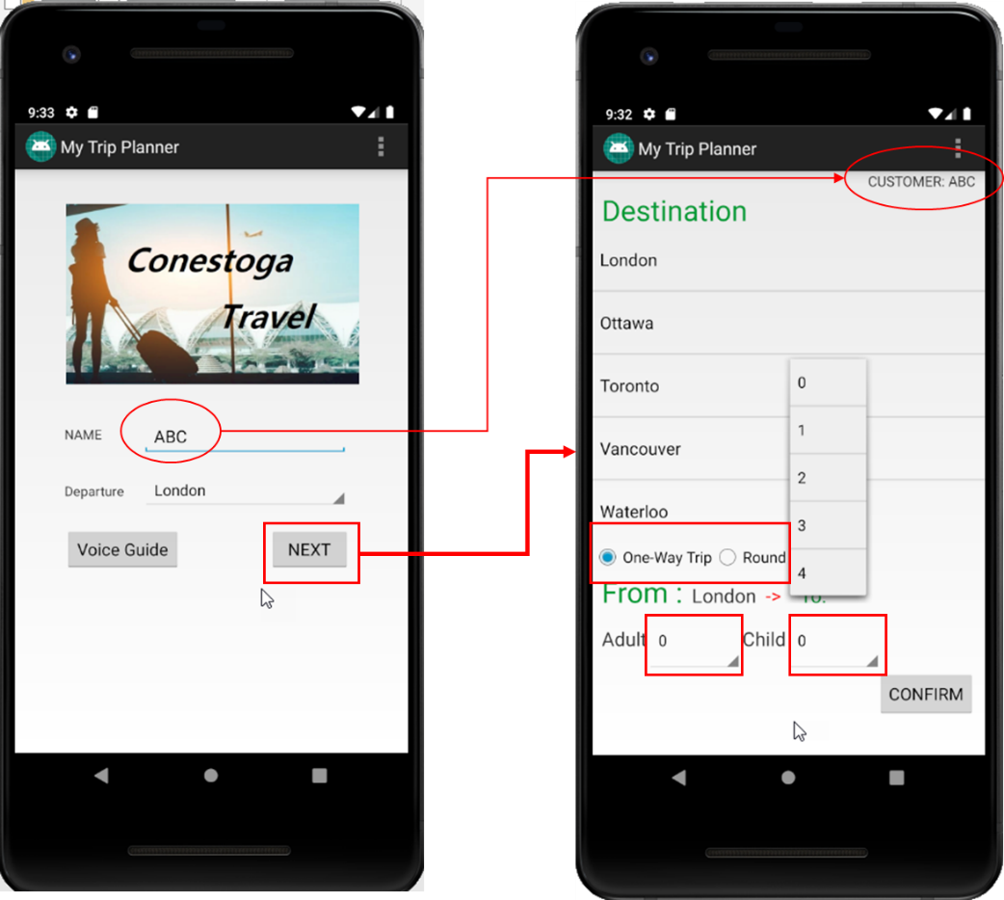

Figure 6 Trip page

## Confirm page (confirm activity)

This page shows detailed information about user's trips (Name of the user, departure, destination, type of flight, and the number of passengers). It indicates only one own person's travel information, not the other's. Furthermore, it has a button which is top left side. It is another "external" intent to link to the live flight tracking site.

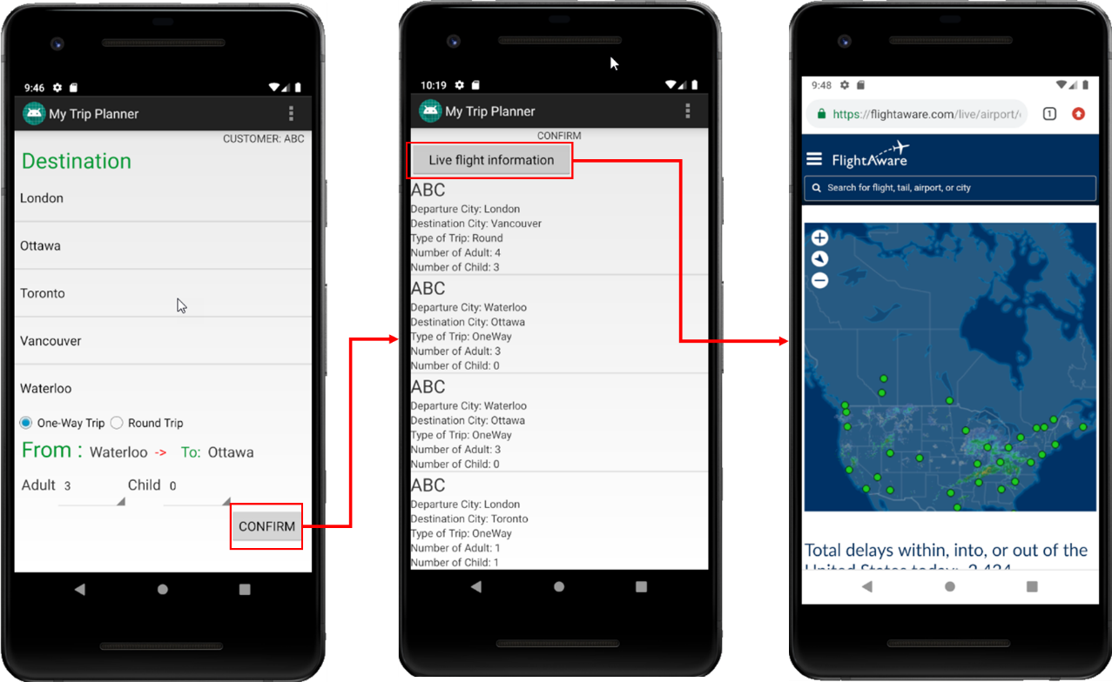

Figure 7 Confirm page